5 Target State Architecture

The 2020 Census architecture is described in the context of the seven domains as shown in Figure 5-1.

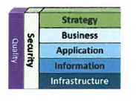

Figure 5-1 2020 Census Architecture Framework

The strategy domain consists of the program vision and mission level business requirements. This domain is not relevant to the Transition Plan, so the reader should refer to the 2020 Census Architecture Document, Section 4.2 for more information on the strategy domain. The other domains are described in the sections that follow.

5.1 Business Architecture The information flows among the primary business operations are highlighted in Figure 5-2. Major interactions and flows are shown via the arrows in the diagram and the key external interfaces are depicted via labeled icons.

Although each operation is presented separately, the operations must work together to achieve a successful Census. Information flows among the operations as the census proceeds from frame development through collection of response data to the publishing and release of the data.

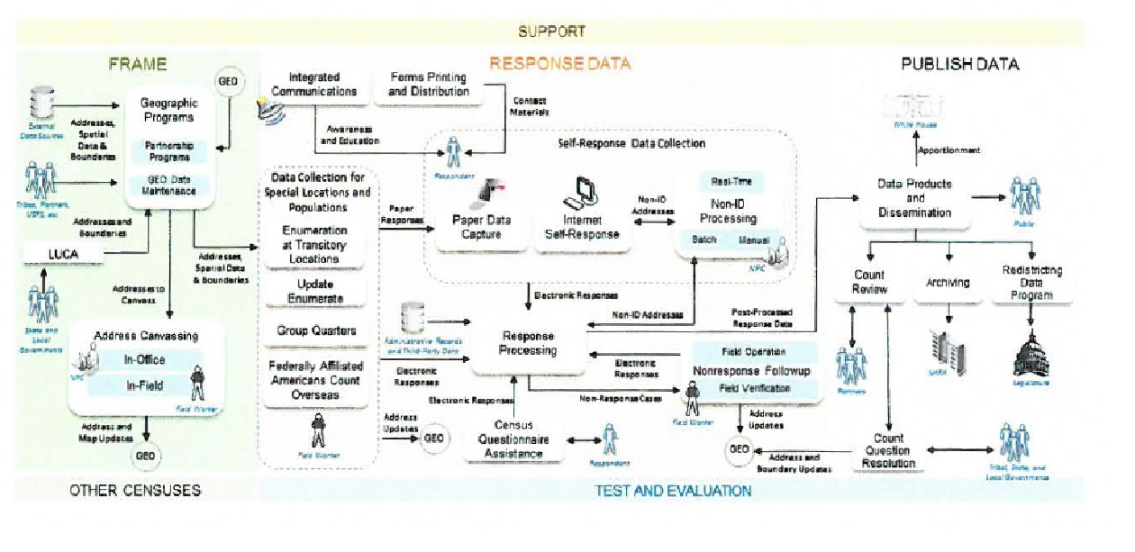

Figure 5-2 High-Level Integration of Operations

41 *2020 Census Enterprise Architecture and Infrastructure Transition Plan*

The 2020 Census Business Architecture describes the functional business process, the relationship, and the geography aspects of the business environment. It is decomposed into multiple operational areas that collectively provide the anticipated capabilities that meet the end-to-end survey lifecycle phase and is grouped into five categories: support, frame development, response data collection, disseminate data, and test, evaluation, and other censuses.

l. The Support segment addresses the needs for HR, IT, and Infrastructure support services of the 2020 Census. Support is comprised of the program management, census/survey engineering, and infrastructure operational sub-categories.

1. The Frame development segment entails activities within the geographic programs, LUCA, and Re-Engineered Address Canvassing. These activities support the task of developing administrative records input, geographic delineations, and address canvassing.
2. The Response Data Collection segment is the largest segment within the 2020 Census Architecture where thirteen distinct operations work together to achieve the data/response information collection goals. The response data collection segment includes a multitude of enterprise and non-enterprise systems, the majority of which are scoped within CEDCaP.
3. The Disseminate data segment is responsible for activities such as accurate production, review, and dissemination of the data collected by the response data collection segment and shared with the stakeholders, the majority of which are scoped within CEDSCI.
4. The test, evaluation, and other censuses segment includes five operational areas with activities that address coverage measurements, matching, follow-ups of the housing units and interviews, enumerations, and experiments.

Figure 5-3 shows how the operations are divided into the business architecture categories. More details about the Business Architecture can be found in Section 4.3 of the 2020 Census Architecture Document.

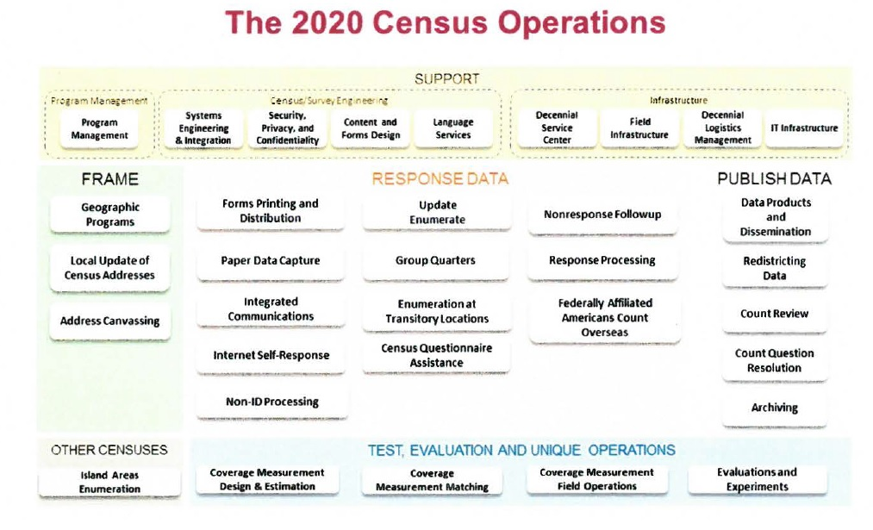

Figure 5-3 2020 Census Operations